**DAILY ONLINE ACTIVITIES SUMMARY**

|  |  |  |  |  |  |  |  |  |
| --- | --- | --- | --- | --- | --- | --- | --- | --- |
| **Date:** | **22-05-2020** | | | | | **Name:** | **Sannidhi P** | |
| **Sem & Sec** | **8th sem B sec** | | | | | **USN:** | **4AL16CS084** | |
| **Online Test Summary** | | | | | | | | |
| **Subject** | | **BDA** | | | | | | |
| **Max. Marks** | | **40** | | **Score** | | | **29** | |
| **Certification Course Summary** | | | | | | | | |
| **Course** | **JAVASCRIPT Tutorial** | | | | | | | |
| **Certificate Provider** | | | **SOLOLEARN** | | **Duration** | | | **30min** |
| **Coding Challenges** | | | | | | | | |
| **Problem Statement: java coding problem** | | | | | | | | |
| **Status: completed** | | | | | | | | |
| **Uploaded the report in Github** | | | | | **yes** | | | |
| **If yes Repository name** | | | | | **Sannidhi1** | | | |
| **Uploaded the report in slack** | | | | | **yes** | | | |

Online Test Details: (Attach the snapshot and briefly write the report for the same)

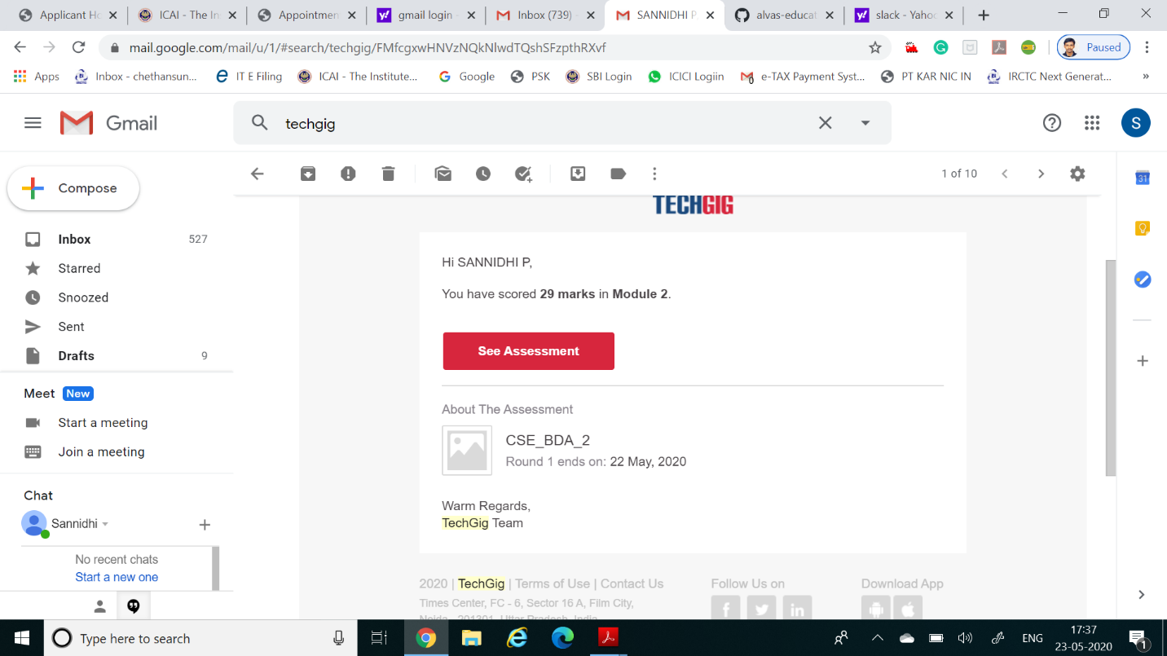

Certification Course Details: (Attach the snapshot and briefly write the report for the same)

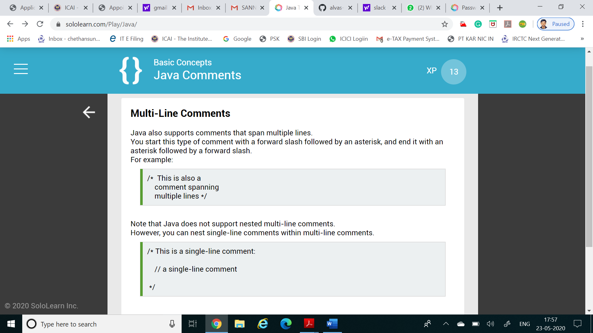

Coding Challenges Details: (Attach the snapshot and briefly write the report for the same)

Coding was given n it was uploaded for github and slack

PROGRAM1

#include stdio.h

int getMissingNo(int a[], int n)

{

int i, total;

total = (n + 1) * (n + 2) / 2;

for (i = 0; i < n; i++)

total -= a[i];

return total;

}

int main()

{

int a[] = { 1, 2, 4, 5, 6 };

int miss = getMissingNo(a, 5);

printf("%d", miss);

getchar();

}